**Task 1: Set Up Basic Firewall Rules**

• **OBJECTIVE**

**Task:** Configure firewall settings on a personal computer.

* Details: Enable and configure Windows Defender Firewall or a similar firewall.

Set rules to block or allow specific applications or ports.

• **STEPS**

1. **Open Windows Defender Firewall Settings**:

* Navigate to the **Control Panel**.

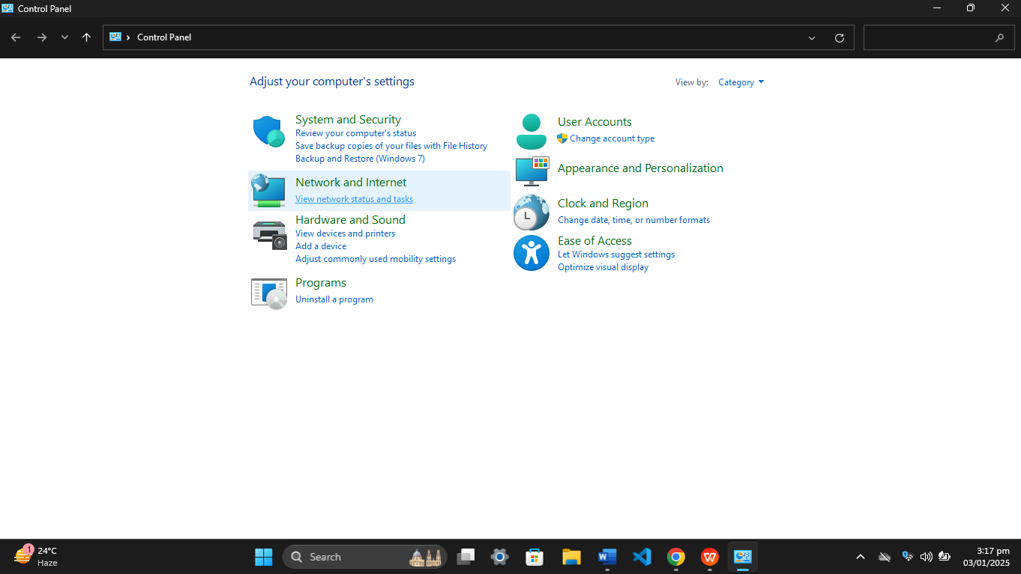

* Select **Security and Maintenance**.

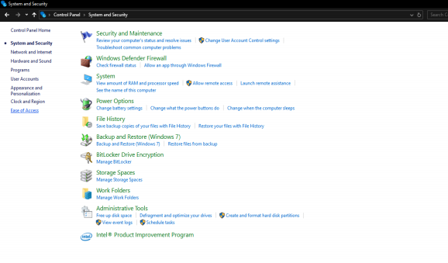

o From there, click on **Windows Defender Firewall**.

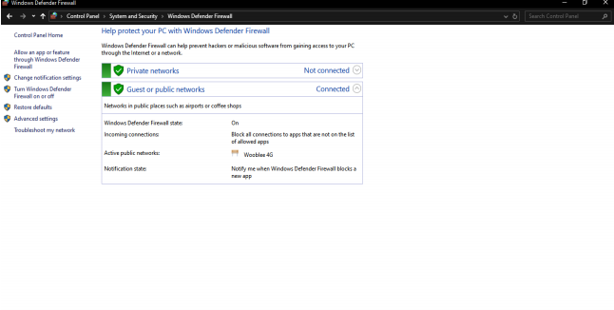

2. **Access Advanced Firewall Settings**:

* In the Windows Defender Firewall window, click on **Advanced Settings** located on the left-hand side. This will open the **Windows Defender Firewall with Advanced Security** console.

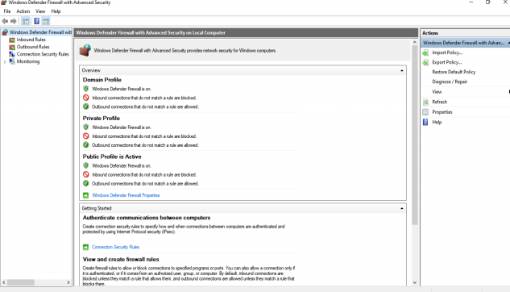

3. **Create a New Inbound Rule**:

* In the Advanced Security console, click on **Inbound Rules** in the left-hand panel.
* Select **New Rule** from the right-hand panel to begin creating a new inbound rule.

4. **Choose Rule Type**:

You will be prompted to select the type of rule you want to create. Options include:

* **Program**: Applies the rule to a specific program.
* **Port**: Applies the rule to a specific port (e.g., TCP or UDP).
* **Predefined**: Applies a rule to predefined services.
* **Custom**: Allows you to specify detailed conditions.

Choose the appropriate rule type based on your needs.

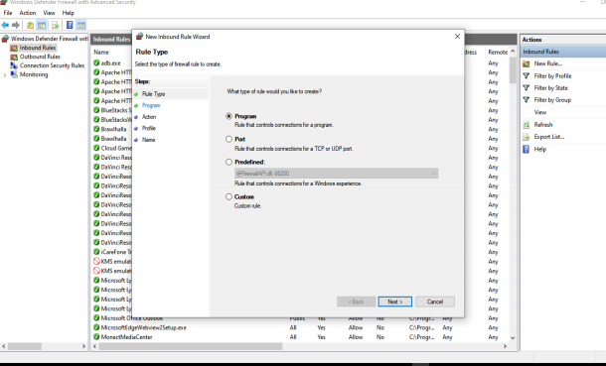

5. **Specify Programs**:

* If applicable, select whether the rule applies to a **specific program** or **all**

**programs** on the system.

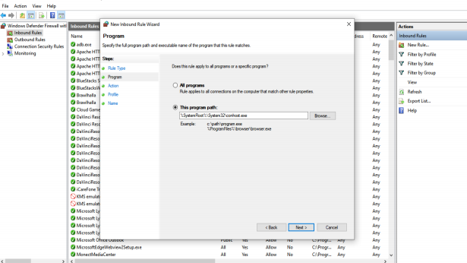

6. **Define Action**:

Choose the action to be taken when the connection matches the conditions

you’ve set:

* ▪ **Allow the connection**.
* ▪ **Block the connection**.
* ▪ **Allow the connection only if it is secured** (requires that the connection is authenticated and encrypted).

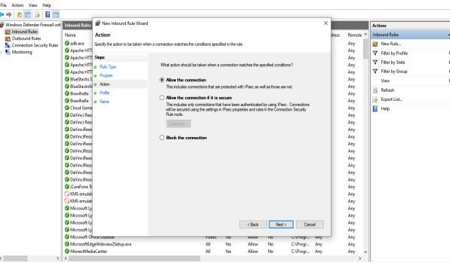

7. **Set Rule Application Conditions**:

* Specify when the rule should be applied:
* ▪ **Domain**: Applies when the computer is connected to a domain.
* ▪ **Private**: Applies when connected to a private network (e.g., home or
* work network).
* ▪ **Public**: Applies when connected to a public network (e.g., coffee shop WiFi).

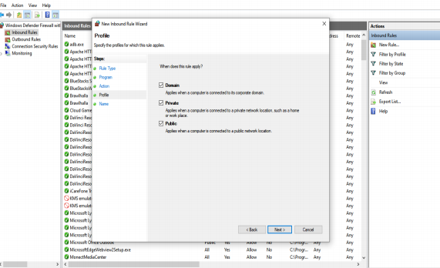

8. **Name and Finalize the Rule**:

* Give the rule a meaningful name (e.g., "Block Port 445") to identify it easily in the future.
* Review the settings, and click **Finish** to apply the rule.

